Christian Scriptures Commentary list: Prof. Drew Leman
Call numbers checked in Library Catalog on April 8, 2026 by JC

Alphabetical organization by title
Commentary Title | Location
 | Reference Collection | Religion Room* | Online
Anchor Bible | R220.77 An21a | 
The IVP New Testament Commentary Series | R225.7 Iv7n |  | --
New Beacon Bible Commentary | --
New Century Bible Commentary | -- |  | --
The New International Bible Commentary | R225.7 N42b |  | --
New International Commentary on the New Testament | R225.7 N42e |  | --
The New Interpreter’s Bible | R220.77 N42a
Paideia | -- |  | --
Reading the New Testament | -- | 225.66 G767r | --
Sacra Pagina | R225.7 Sa14 | -- | --
Smyth and Helwys | -- | 222.12 J659e | --
Tyndale New Testament Commentary | --
Wesleyan Bible Commentary | R220.7 W516w | -- | --
Word Biblical Commentary | R220.77 W891 |  | --


*Use Library Catalog to look up call numbers. Search by commentary series title AND the name of the book of the Bible for your passage, like this:

Organized by format & location

Online
- Anchor Bible
- The New Interpreter’s Bible
- Tyndale New Testament Commentary
- New Beacon Bible Commentary

Books

Reference Books
How to use:
- Located on 1st floor, Benner Library
- May be used anywhere in the Library
- These books can not be checked out
- Return to reshelving cart when done

Full Bible commentaries—shelved together as a set
Commentary Series Title | Call number
Wesleyan Bible Commentary | R220.7 W516w, vol. 1-6
Anchor Bible | R220.77 An21a, vol. 1-30
The New Interpreter’s Bible | R220.77 N42a, vol. 1-12
Word Biblical Commentary | R220.77 W891, vol. 1-52

New Testament only Bible commentaries— shelved together as a set
Commentary Series Title | Call number
The IVP New Testament Commentary Series | R225.7 Iv7n, vol. 1-20
The New International Bible Commentary | R225.7 N42b, vol. 1-18
New International Commentary on the New Testament | R225.7 N42e, vol. 1-27
Sacra Pagina | R225.7 Sa14, vol. 1-18

Circulating Books—shelved according to book of the Bible
How to use:
- Located on 3rd floor, Benner Library
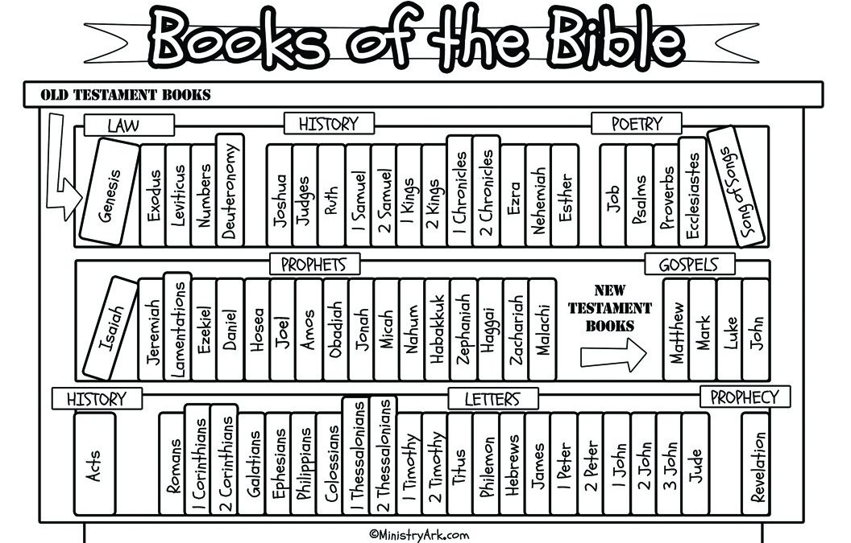
- Use Library Catalog to look up call numbers. Search by commentary series title AND the name of the book of the Bible for your passage, like this:
- Use this graphic representation of the books of the Bible, in order, to navigate the shelves
- Bring to Circulation Desk on 1st floor to check out
Recommended commentary series
- Anchor Bible
- The IVP New Testament Commentary Series
- New Beacon Bible Commentary
- The New International Bible Commentary
- New International Commentary on the New Testament
- The New Interpreter’s Bible
- Paideia
- Tyndale New Testament Commentary
- Word Biblical Commentary

