College Writing II: CSE
Spring 2026
Updated Jan. 7, 2025
You’re about to begin a semester-long research journey. Conducting research and doing academic writing takes practice. This packet contains instruction, strategies, and exercises to help you learn and master the research process, effective strategies, discipline-specific databases, and AI tools are included. Librarian advice: Accept coaching and allow time for trial and error. If you persist, you will grow!

Start with what you know
- Type your topic/area of interest (in one sentence)

Main ideas (1-2 keywords)
- Break your topic into the MOST IMPORTANT parts by listing 1-2 keywords that describe the main points of your topic in the top row of this table:

- Next, list narrower or related terms in the shaded rows (above). Add synonyms. You will use these as your search words in the database search exercises on pages 3-5.

Next steps:

Research Tips

Sources: Where to find them

Format of topic
Your topic should | Simply describe or define | Be measurable | Be neutral | Take a position
APA |  | 
CSE
MLA
CMS


Okay to use these source types? | APA | CSE | MLA | Chicago (CMS)
Background: Definitions, facts, dates, theories, statistics
Original texts: Novels, scripture, etc.
Peer reviewed/research articles: Review articles, theories, original research |  |  | Yes; use as evidence for your position
Trade magazines | ? Possibly—ask prof.
Newspaper & popular magazine articles | No—unless prof. gives permission

Using context clues from the results list
Use these parts of the results list to improve and revise your searches:
- Title: Skim for relevance to your topic
- Subject Headings: Use these words to improve your next search
- Source type: Confirm the source is what you’re looking for
- Abstract: Skim the summary to confirm this source is worth reading. If so, click on full text or request through Interlibrary Loan (ILL).
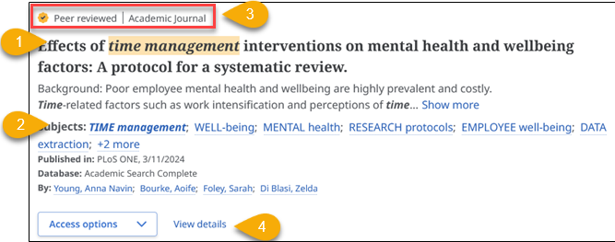

Database Exploration & Reflection

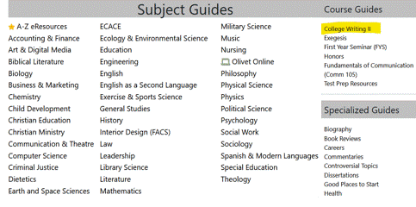
Instructions
- Go to the College Writing II Library course page: Library.olivet.edu >
Subject Guides >
College Writing II

- You will explore four databases using your search words on page one. Allow at least 5-minutes per database.
  - Credo Reference
  - Library Catalog
  - EBSCO eBooks
  - Academic Search Complete

Note: Each database in these exercises has a special feature that you need to explore.
You’ll be prompted to reflect on the usefulness of each database. Reflecting helps solidify learning!

…reflections require students to reexamine and evaluate the changes in their perceptions, assumptions, knowledge, and understanding in light of the experience… Students can analyze the experience including their own reactions, behaviours and approaches in retrospect, and should be asked to consider what their expectations would be/ how they would approach similar experiences in the future.

Centre for Pedagogical Innovation. c2025. Role of reflection. St. Catharines (ON, Canada): Brock University; [accessed 2025 Jun 20]. https://brocku.
ca/pedagogical-innovation/resources/experiential-education/role-of-reflection/#1540494768752-5a02f198-73d2.

 Open Credo Reference
- In Credo Reference, search for background info. (definitions, theories, key dates & people)
- Narrow your topic using the Mind Map (see screenshot).
- Citation note: In this database, “Chicago” style provides the closest citation example for CSE users.
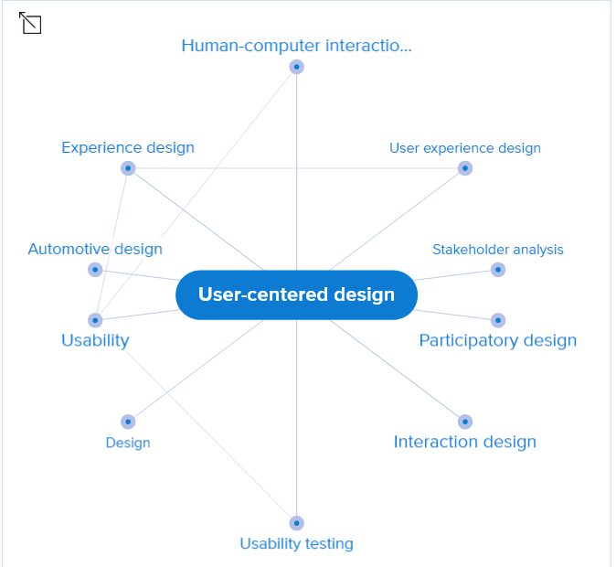
REFLECT
Record your thoughts on Credo here:
Kind of sources/results:

Useful?
How? Why not?

Library catalog
- Search for a book. For this project you might only use sections from a single chapter per book.
- Sort results by date to see the newest titles at the top of the results list (see screenshot).
- Citation note: Yea! the Library Catalog provides a citation example in CSE style.
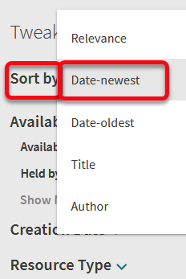

REFLECT
Record your thoughts on the Library Catalog here:
Kind of sources/results:
Useful?
How? Why not?
Do you prefer eBooks or print books?

EBSCO eBooks: Search for eBooks.
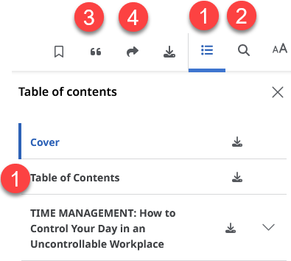
Do a keyword search box at the top of the screen to search for an ebook.

- Click on title in results list
- Choose “Access Now (eBook)” to read it online.
- Look for these features (see screenshot):
- Table of contents that includes chapter download links.
- Search within the book
- Citation generator. Note: In this database, “Chicago” style provides the closest citation example for CSE users.
- [Share] a link to this eBook
REFLECT
Record your thoughts on EBSCO eBooks:
Kind of sources/results:
Useful?
How? Or why not?

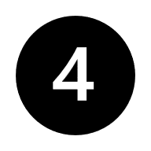Academic Search Complete: Task 1: Refine with Subject words. Task 2: Look for (and try!) citation chaining tools—available only for some articles.

Task 1:
Start by doing a keyword search
- Use filters under search box to limit results to:
  - Peer reviewed
  - Published in past 10 years
  - Academic journal articles
- Click on “All filters” option to open panel with additional limits
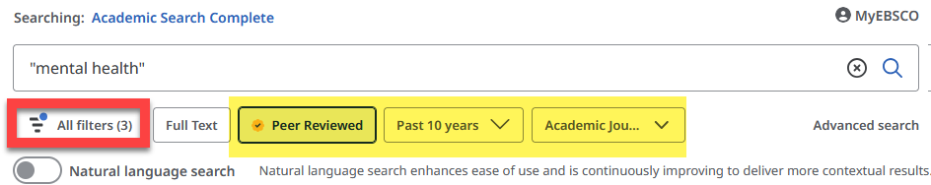
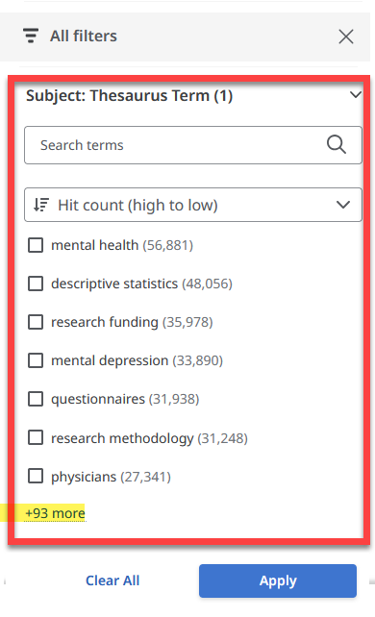

  - Scroll to “Subject: Thesaurus Term”
  - Choose as many as you want
Tip: Use these terms to revise your search words and topic!
  - Click Apply
  - Skim the results list for relevance. E.g. Ask yourself:
    - Are these articles relevant to my area of inquiry?
    - Interesting to me?
    - Related to each other or wildly different?
Task 2:
Skim the results list again. Look for records with the “Cited by” button. Click on it to see newer articles who cited this one. This new database features makes citation chaining easier.
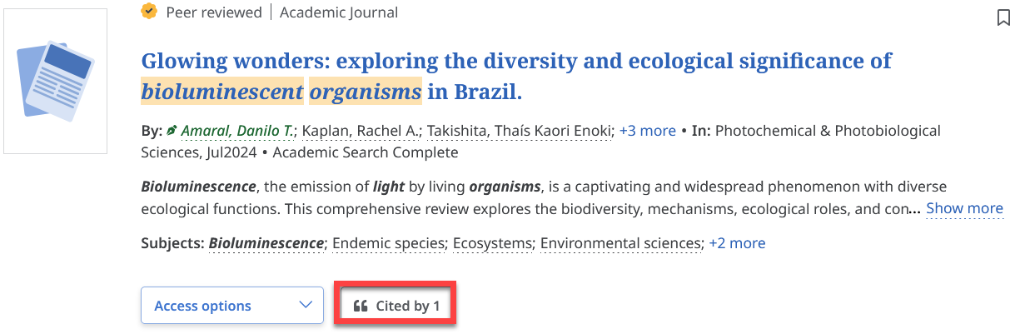

REFLECT
Compare the results you got with keyword -vs- subject words from the database
Which search gave you “better” results?

Which search strategies help you organize your thoughts?

Revise & Evaluate
- Which search words are NOT working?

5. List new search terms* | I. | II.
*Discovered by reading titles, abstracts and subject words in database searches

6. Revised topic/position

7. Plan your use of subject-specific article databases:
Visit the list of Library Subject Guides and choose one that best fits your research topic/major
Library.olivet.edu > Subject Guides

Which Subject Guide(s) could you use for your project?

Look at the recommended databases on the next page.
Which one(s) will you use when it’s time to find peer reviewed, scholarly sources?

Recommended Databases: CSE
Discipline | 1st database | 2nd Database
Biology  including Zoology | Science Direct | Academic Search Complete
Chemistry | American Chemical Society | Science Direct  Academic Search Complete
Earth & Space Sciences | GeoRef  Apply “Linked Full Text” option  If you don’t find what you need, remove that limit and use “Check for Alma full text” and “Request this item (ILL)” options under “Access Options” | Academic Search Complete

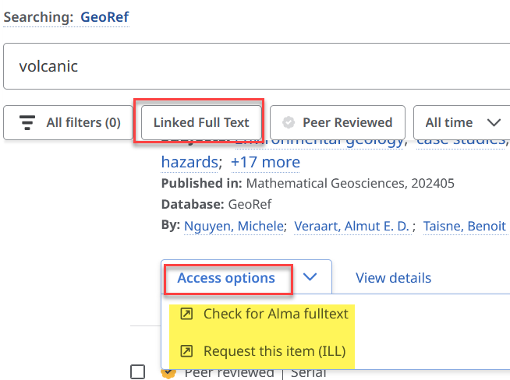

HELP

INFO Desk Hours (1st-Floor, Benner Library)

815-939-5355 | ONULibrary@olivet.edu | Schedule an Appointment

Mon., Tues, Weds, Thurs. Friday Saturday Sunday

8am-4pm & 6-10pm 8am-5pm No service 6:30-10pm

