College Writing II: APA
Fall 2026
Updated August 19, 2026 by JC
You’re about to begin a semester-long research journey. Conducting research and doing academic writing takes practice. This packet contains instruction, strategies, and exercises to help you learn and master the research process, effective strategies, discipline-specific databases, and AI tools are included. Librarian advice: Accept coaching and allow time for trial and error. If you persist, you will grow!

Start with what you know
- Type your topic/area of interest (in one sentence)

Main ideas (keywords)
- Break your topic into the MOST IMPORTANT parts by listing 1-2 keywords that describe the main points of your topic in the top row of this table:

- Next, list narrower or related terms in the shaded rows (above). Add synonyms. You will use these as your search words in the database search exercises on pages 3-5.
Next steps:

Research Tips

Sources: Where to find them

Format of topic
Your topic should | Simply describe or define | Be measurable | Be neutral | Take a position
APA |  | 
CSE
MLA
CMS


Okay to use these source types? | APA | CSE | MLA | Chicago (CMS)
Background: Definitions, facts, dates, theories, statistics
Original texts: Novels, scripture, etc.
Peer reviewed/research articles: Review articles, theories, original research |  |  | Yes; use as evidence for your position
Trade magazines | ? Possibly—ask prof.
Newspaper & popular magazine articles | No—unless prof. gives permission

Using context clues from the results list
Use these parts of the results list to improve and revise your searches:
- Title: Skim for relevance to your topic
- Subject Headings: Use these words to improve your next search
- Source type: Confirm the source is what you’re looking for
- Abstract: Click on “View details” link in order to skim the article summary and confirm this source is worth reading. If so, click on full text or request through Interlibrary Loan (ILL).
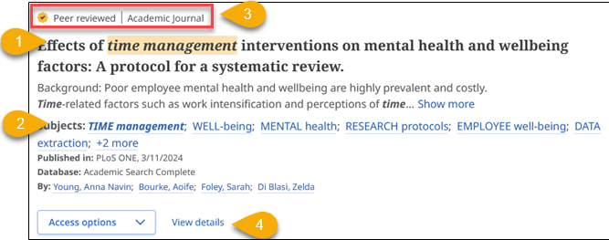

Database Exercises

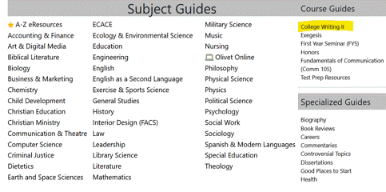
Instructions
- Go to the College Writing II Library course page: Library.olivet.edu > Subject Guides > College Writing II

- You will explore four databases using your search words on page 1. Allow at least 5-minutes per database.
  - Credo Reference
  - Library Catalog
  - EBSCO eBooks
  - Academic Search Complete

Note: Each database in these exercises has a special feature that you need to explore.
You’ll be prompted to reflect on the usefulness of each database. Reflecting helps solidify learning!

…reflections require students to reexamine and evaluate the changes in their perceptions, assumptions, knowledge, and understanding in light of the experience… Students can analyze the experience including their own reactions, behaviours and approaches in retrospect, and should be asked to consider what their expectations would be/ how they would approach similar experiences in the future.

Centre for Pedagogical Innovation. (n.d.). Role of reflection. Brock University. https://brocku.ca/pedagogical-innovation/resources/experiential-
education/role-of-reflection/#1540494768752-5a02f198-73d2

Open Credo Reference
- In Credo Reference, search for background info. (definitions, theories, key dates & people)
- Narrow your topic using the Mind Map on the right OR look under the number of results and use the Filters button to narrow by Subjects
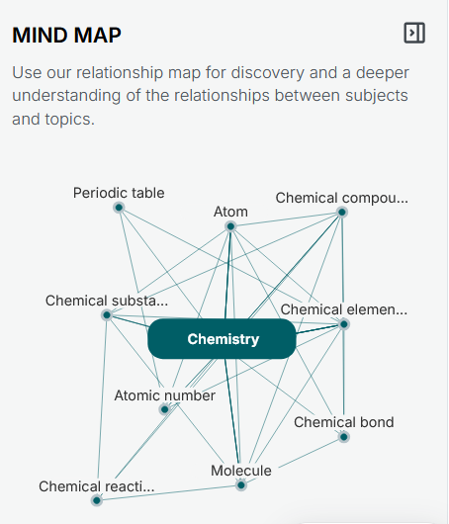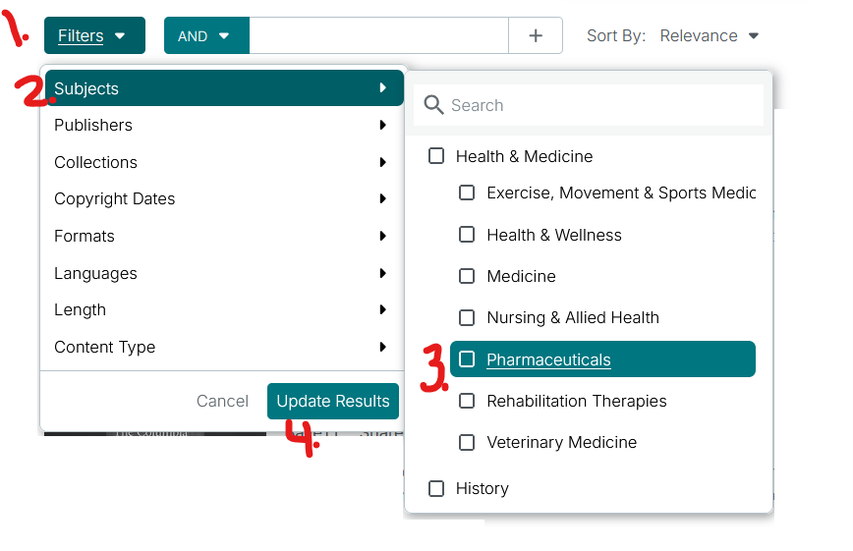

REFLECT: Credo
Record your thoughts on Credo here:
Kind of sources/results:

Useful?
How? Why not?

Library catalog
- Search for a print or eBook in the Library catalog. For this project you might only use sections from a single chapter per book.
- Sort results by Date-newest (see screenshot).
- Consider limiting to ebooks by choosing “Available online”
- Need more? Expanding your search to I-Share partner libraries. Insert tutorial link.
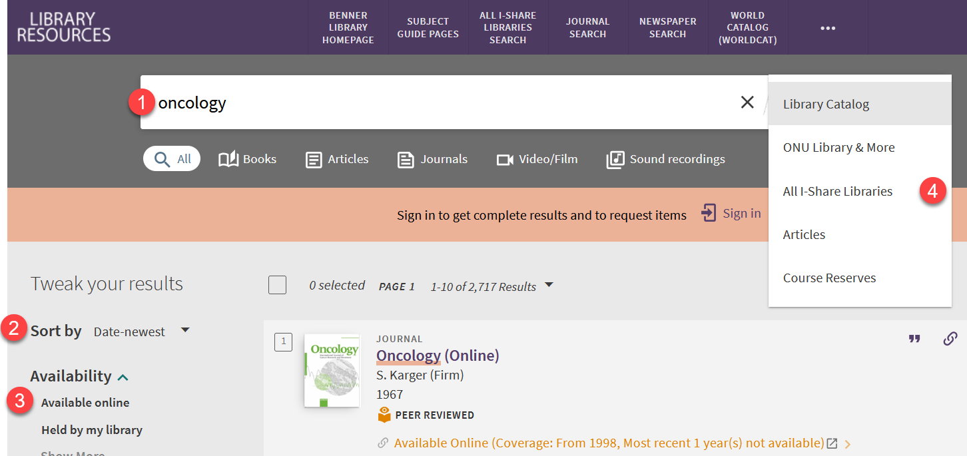
REFLECT
Record your thoughts on the Library Catalog here:
Kind of sources/results:
Useful?
How? Why not?
Do you prefer eBooks or print books?

Academic Search Complete:

Task 1: Refine initial search with Subject words.
- Start by doing a keyword search in Academic Search Complete
- After you search, use filters under search box to limit results to:
  - Peer reviewed
  - Published in past 10 years
  - Academic journal articles
- Click on “All filters” option to open panel with additional limits
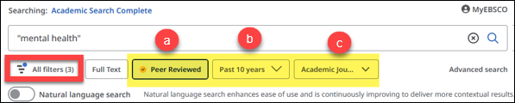
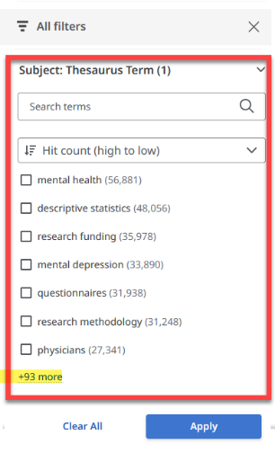
- Scroll to “Subject: Thesaurus Term”
- Choose as many as you want
- Tip: Use these terms to revise your search words and topic!
- Click Apply
- Skim the results list for relevance. E.g. Ask yourself:
    - Are these articles relevant to my area of inquiry?
    - Interesting to me?
    - Related to each other or wildly different?

Task 2: Use citation chaining tools (not available for all articles)
- Skim the results list again. Look for records with the “Cited by” and “More like this” buttons.
- Click on “Cited by” to see newer articles who cited this one. This new database features makes citation chaining, a powerful search technique, easy!
“More like this” is an AI-powered tool that recommends five more articles.
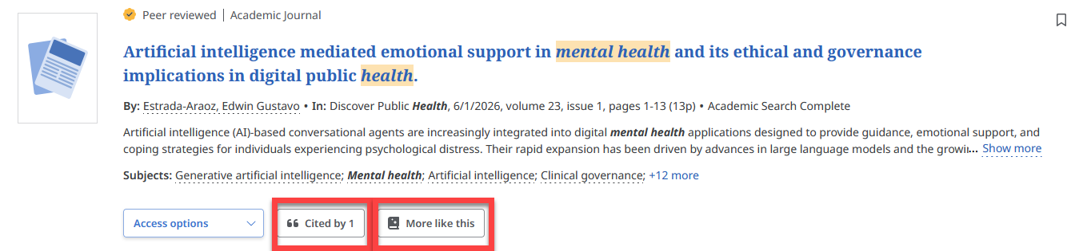

REFLECT
Compare the results you got with keyword -vs- subject words from the database
Which search gave you “better” results?

Which search strategies help you organize your thoughts?

Evaluate & Revise
- Which search words are NOT working?

5. List new search terms* | I. | II.
*Discover by reading titles, abstracts and subject words in database searches

6. Revised topic/position

7. Plan your use of subject-specific article databases:
Visit the Library’s Subject Guides and choose one that best fits your research topic/major:
Library.olivet.edu > Subject Guides

Which Subject Guide(s) could you use for your project?

Look at the recommended databases on the next page.
Which one(s) will you use when it’s time to find peer reviewed, scholarly sources?

Recommended Databases: APA
Discipline | 1st database | 2nd Database
Art & Music | Humanities Source Ultimate | JSTOR Collection Note: Before searching, scroll down to “Journal Filter” in order to limit by discipline.  Academic Search Complete
Business | Business Source Ultimate  ABI/INFORM Global | Small Business Source
Communication  Theater | Communication Source | Choose from Art & Music recommendations above.
Criminal Justice | Criminal Justice Abstracts | Academic Search Complete (broader than database in column 1)  Violence & Abuse Abstracts (narrower than database in column 1)
Education | Education Research Complete | Professional Development Collection
EXSS | SPORTDiscus | Academic Search Complete
FACS | Academic Search Complete | Science Direct (Dietetics)  AltHealthWatch (Dietetics)  Business Source Ultimate (Interior Design)
Nursing | CINAHL Complete | Health Source Nursing/Academic Edition
Psychology | PsycARTICLES  Note: This database is all full text  Psychology & Behavior Sciences Collection (good for child and adolescent psychology; counseling) | PsycINFO  Note: This database from the APA is bigger than either in column 1. It contains everything in PsycARTICLES.
Social Work & Sociology | Sociology Source Ultimate | Academic Search Complete (broader than Socy. Source Ultimate)  ****************************************************************  Narrower than Socy. Source Ultimate:  Violence & Abuse Abstracts  Family & Society Studies Worldwide
STEM | Science Direct | Academic Search Complete

INFO Desk Hours (1st-Floor, Benner Library)

815-939-5355 | ONULibrary@olivet.edu | Schedule an Appointment

Mon., Tues, Weds, Thurs. Friday Saturday Sunday

8am-4pm & 6-10pm 8am-5pm No service 6:30-10pm

