ACCT 470: CORPORATE & OTHER ENTITY TAX

Journal titles and online full text coverage

Law Review Journals
- New York University Tax Law Review: 2000-present in Nexis Uni
- Virginia tax Review: 2004-present in ABI/INFORM Global

Professional Journals
- Business, Entrepreneursip & Tax Law Review: 2017-present in Nexis Uni
- Journal of Accountancy: 1987-present in ABI/INFORM Global
- Journal of Taxation: 2002-present in ABI/INFORM Global
- Practical Tax Strategies: 2002- present in ABI/INFORM Global
- Tax Adviser: 1987-present in ABI/INFORM Global

How to access the full text

ABI/INFORM Global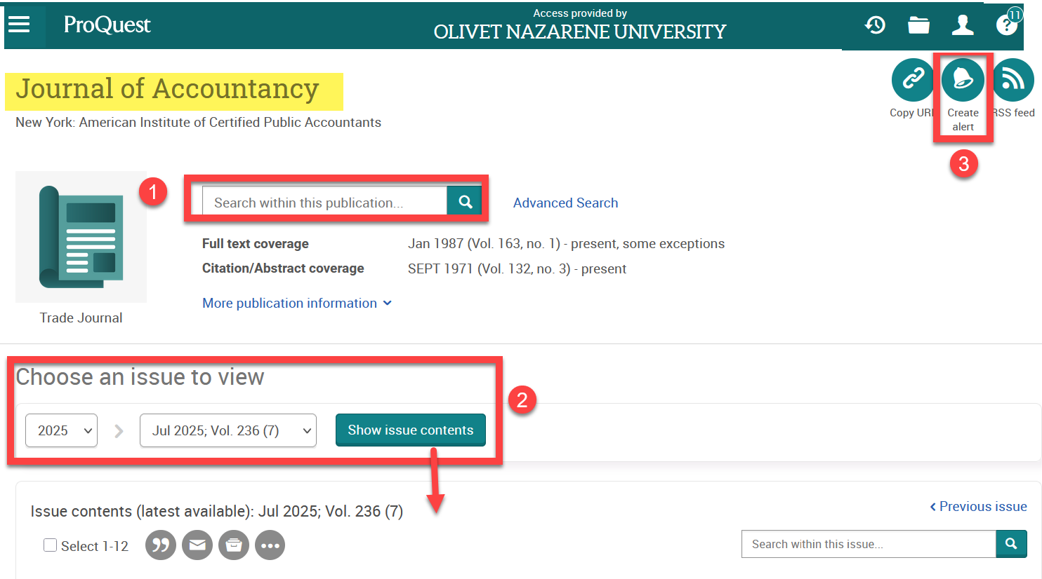
- Seach within all issues of the journal. Do this when you know a title, author, or just have a keyword.
- Change date, volume, issue. Do this when you know the citation info.
- Make an account and set up an alert on specific keywords in this journal.

Nexis Uni


Page created by Jasmine Cieszynski August 29, 2025. Updated July 7, 2026.

