Gale in Context: Opposing Viewpoints
Benner Library subscribes to a database from a vendor named Gale. Opposing Viewpoints may be appropriate for persuasive speech topics and other research on contemporary issues.

Content
- Results: Results include many different types of sources: maps, statistics, news articles, video, audio, reference sources, primary sources, and periodicals.
- Content: The content comes from authoritative publications, and sources which are carried by the vendor equipping researchers with content for reflection, synthesis, and analysis.
- Search Options: It's easy to search by keyword or browse by topic.

Unique Features
Opposing viewpoints contains some articles written in a pro/con format. It also contains overviews of special interest groups and agencies with the U.S federal government.

To search
- Type a few keywords in the search box or click the lightbulb icon to “Browse Issues.”
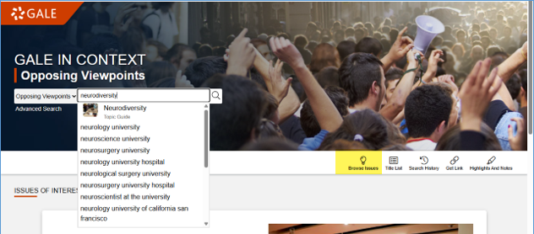

- Some search terms have featured overviews. When available, they appear at the top of the page. Click "read overview" to see an encyclopedia like summary of the topic, plus links to similar articles from news sources, reports and other formats.
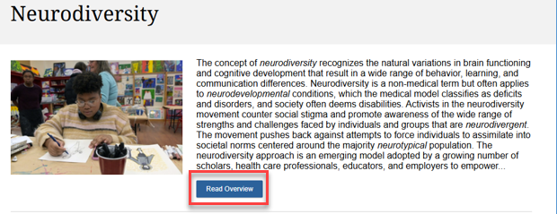
- Check the grey bar at the top of your results list, for a summary of source types and how many hits match your search words. For example, this search gives us fourteen featured viewpoints, four reference articles, and five videos. Click on the category heading to connect to the rest of the results.
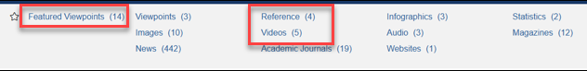

- Scroll down to see headers for each source type, plus the first few results in that category.
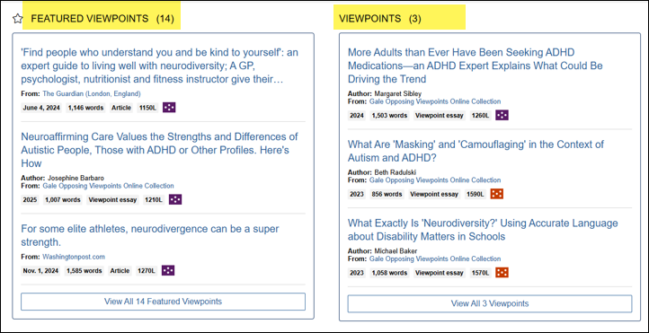

- Related topics are highlighted with thumbnail images at the top of your results screen. Click to connect.
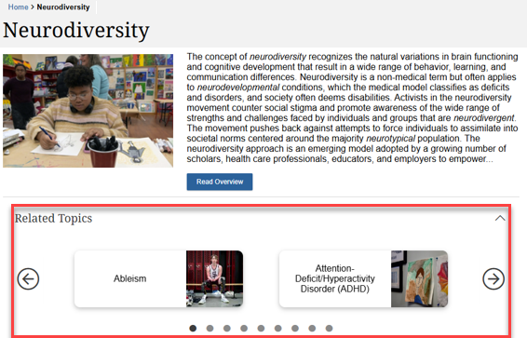

- If you choose one of the Featured Viewport articles, the database provides a special section at the top of the page that summarizes the article content and points out issues for readers to consider. Use links in the sidebar to connect to more resources.
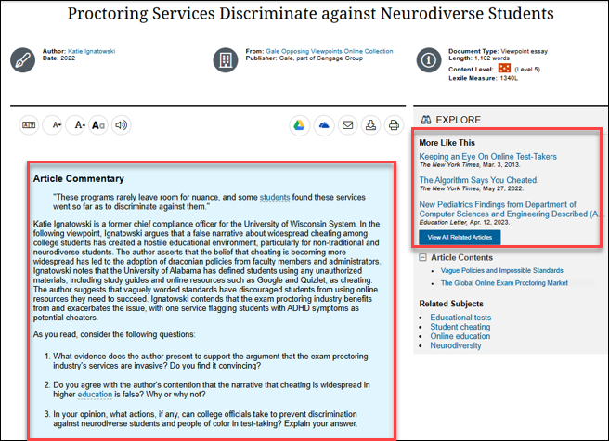

- Scroll to the bottom of all articles to find citation tools. Change the citation style from MLA to APA as needed.
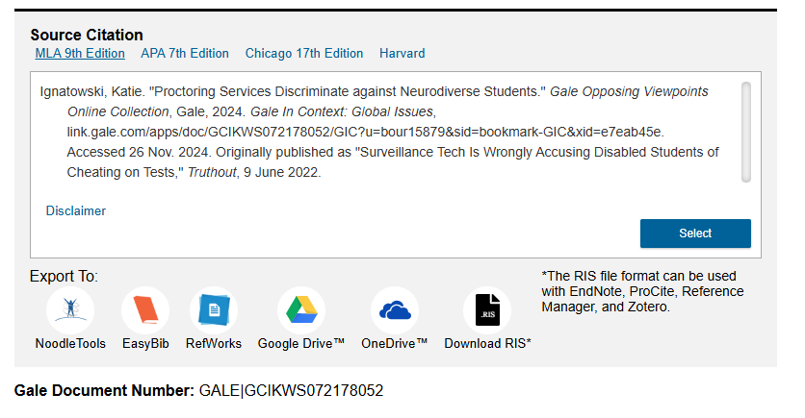

Questions?
Contact the INFO desk or go to the ‘Ask a Librarian’ page at library.olivet.edu

