Finding Scholarly Articles in the new EBSCOhost interface

Overview
In this tutorial you will learn how to use search features in the 2025 EBSCOhost interface to meet the requirements of a scholarly article assignment. We also highlight a few database tools to improve efficiency and organization.
Start by reviewing your assignment’s requirements. Then go to the library homepage.
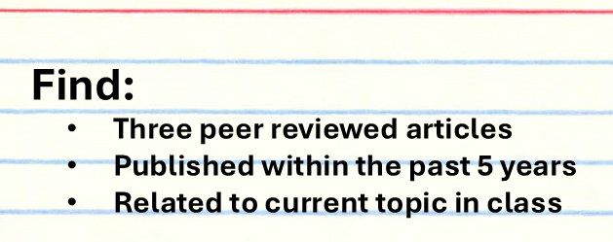

Searching
- Click on Subject Guides
- Choose the Guide for your current course or major.
  - All Subject guides featured recommended article databases in the left column.
  - To read the description of each database, click on the triangle next to the title.
  - Click on the title to connect to the database.
Academic Search Complete is a good starting place for most majors at Olivet.
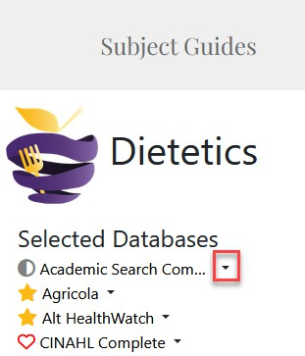
Before starting your search, take a moment to break your research topic into manageable parts.
For example, if your topic is “What is the impact of caffeine on sleep?” It could be simpliﬁed to a search for articles about “caffeine AND sleep.” We’ll come back to the “impact” a bit later.
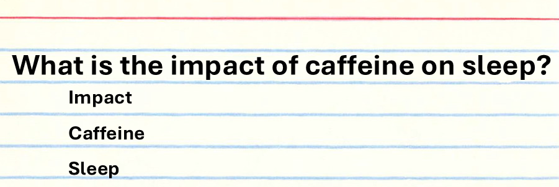
As you type your search words, remember the assignment requirements.
- EBSCOhost makes it easy to limit by peer review and date.
- You don’t need to worry about full text as our Interlibrary Loan team can quickly get you access to almost any article. Our Interlibrary Loan team is award-winning, and we have automated connections between all of our subscription databases, so there is usually no need to limit yourself to full text at this point.
- I’ll search for caffeine AND sleep.
- Then limit to peer reviewed articles from the past 5 years.
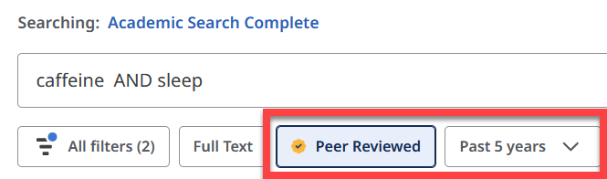
- Check the number of results.
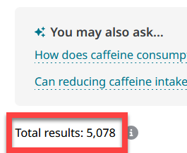
- If you think the number of results is too many to browse, you can add another search word, perhaps for:
- A speciﬁc population or issue in your ﬁeld
- Or you could think of search words that describe the kind of impact you want to learn about
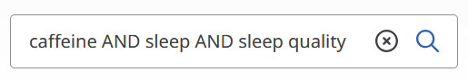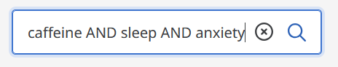
- If you can’t think of another search word to add on your own, skim the results list. Speciﬁcally, concentrate on relevant terms in the article title or in the listed “Subjects.”
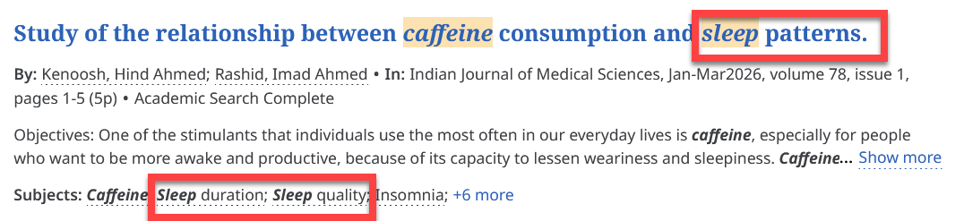
- Keep trying different combinations of search words in this database, or use tools in the left column to
- Try a different database until you ﬁnd articles that interest you and meet the assignment requirements.
- Research is messy and takes real time and effort. And if you’re having trouble, stop by or contact the INFO Desk to get some help.
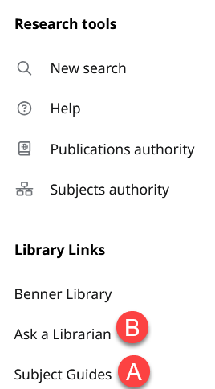

Access Options
Let’s shift gears to actually reading articles, once you ﬁnd something relevant.
- Before looking into access options, consider reading the abstract to conﬁrm that an article will really help you. To see the full abstract, click on the article title.
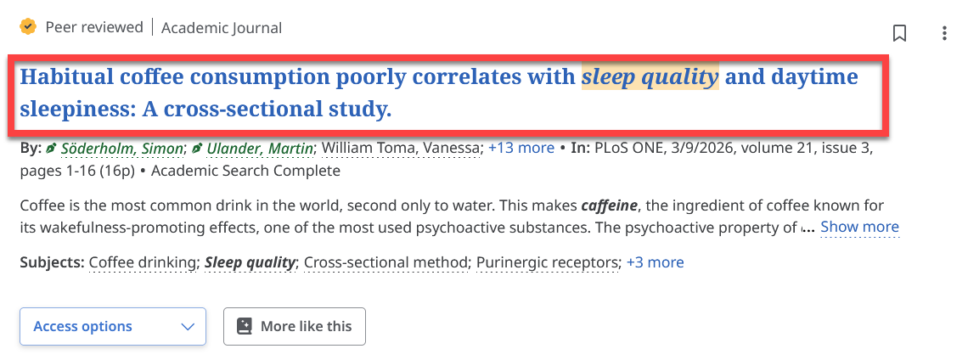
- Scroll to ﬁnd the abstract. Conﬁrm that it’s relevant to your topic and makes sense when you read through it.
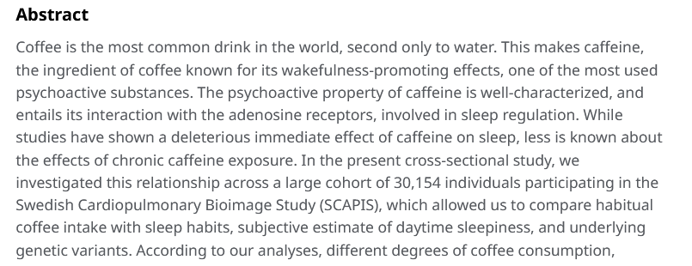
- When you’re satisﬁed that you want to read more, return to the top of the page for Access Options.
- If there is only a .pdf or retyped, HTML version available, the Access Options will look like one of these:
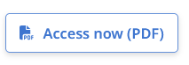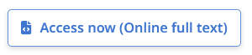
  - If both formats are available, or the article is not included in this database, you’ll see a different Access Option icon:
    - When you click on it, you might be given the option to choose the HTML or .pdf:
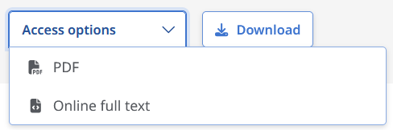
    - Or you might be prompted to check for full text using this link to our other Benner databases.
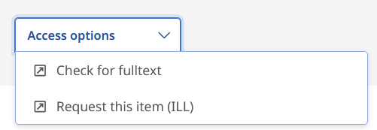
      - If we have the full text, it will open in a new window.
      - If we do not have the full text, we can get it for you for free, from a partner library. Our Interlibrary Loan team is fast! When you make a request, you’ll end up with a .pdf of the article as an attachment in your ONU email. Keep the ﬁle forever.
    - To make a request, go back to the tab with the database and choose "Request this item (ILL).” The article details are already ﬁlled in on this form.
      - Add your Olivet contact info.
      - When you get to the section asking what we should do if the library needs to pay for this article, use it to give us feedback about how badly you need THIS article. Rarely, we’re asked to pay for an article. If this happens with your request, indicate if you want us to recommend something else, check with you by email before paying, or get the article no matter what? In any case, YOU will not pay. The library already has a budget for these rare cases, so it’s okay to ask for what you need.
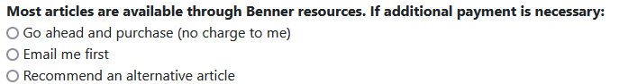

Database Tools
Now let’s look at how to ﬁnd the citation, save, share, and download tools in EBSCOhost. Most database companies provide these same tools to help researchers stay organized.
- You can access the tools from the results list, by clicking on the three dots to the right of the citation.
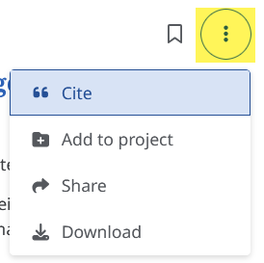
- If you’re already on the detailed view of your article, look at the top of the page, above the title, to ﬁnd these tools.
- Here’s a pro tip:
  - Use the citation tool.
  - Choose the citation style for your assignment.
  - Then click on “Copy to clipboard.”
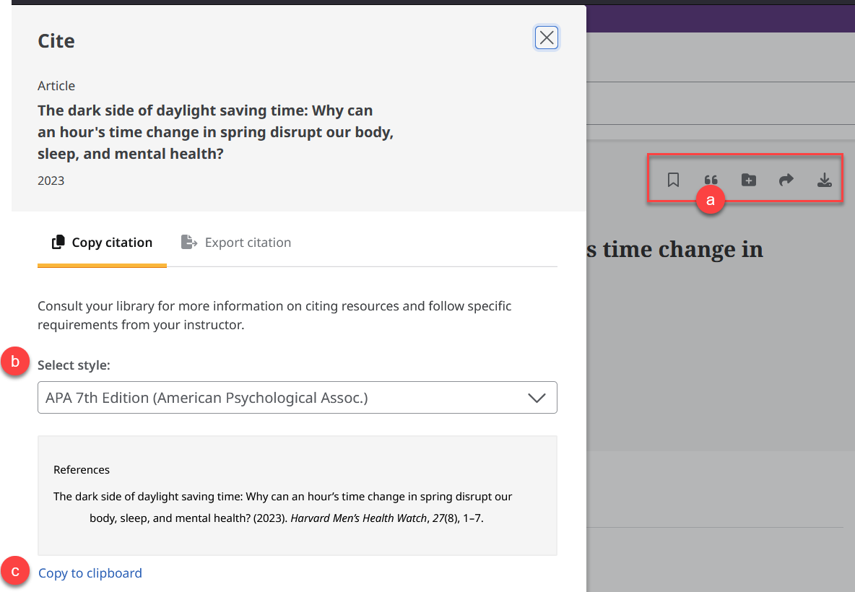
Remember to compare this citation with a style guide or materials from your professor. Incorrect capitalization is a common problem in citations generated by article databases.

Wrap Up
Thanks for watching this video about how to use assignment requirements to inform your use of search words and limits. Utilize the abstract, Access Options, and organization tools provided by the EBSCOhost interface for maximum efficiency!

