CINAHL Basics
This tutorial outlines the basics of using the CINAHL Nursing and Health database.

Navigation
- Access the Benner Library homepage at library.olivet.edu.
- Click on “Subject Guides” on the home page.
- Click on the “Nursing” subject guide.
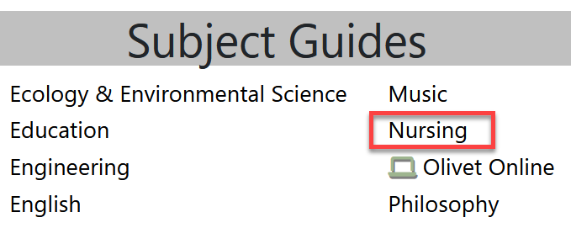
- Navigate to the CINAHL Complete database.
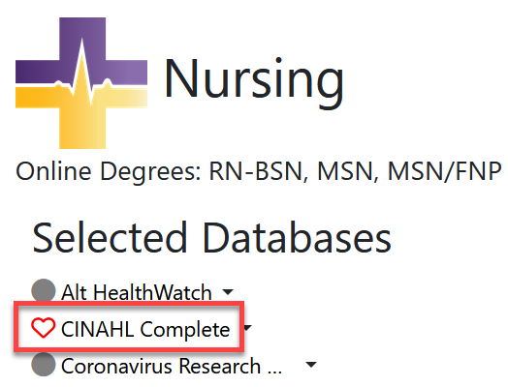

Searching in CINAHL
- Type in search terms and press enter.
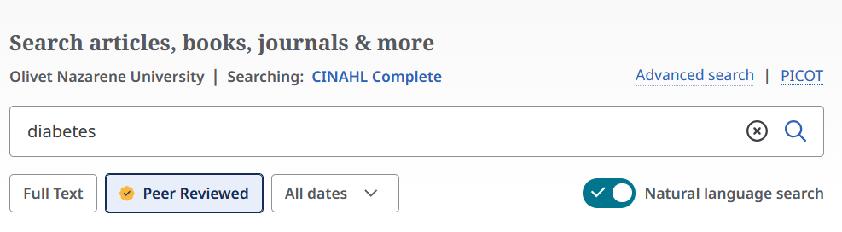
- If results are too broad, refine the search results to peer reviewed journals and make sure that the publication date is within the range of the assignment.
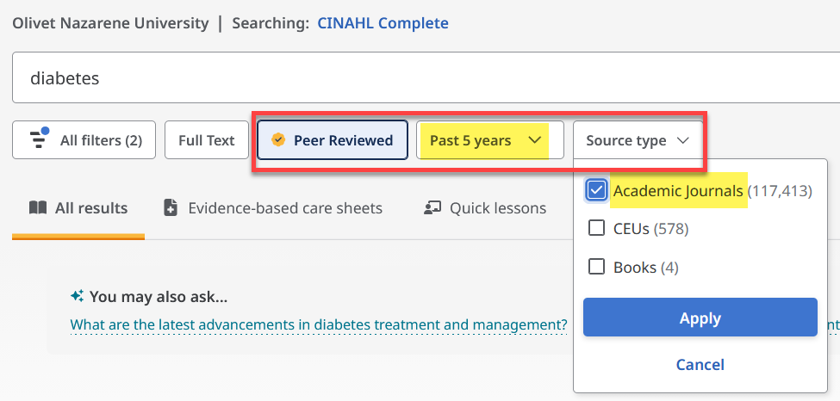
- From the results list, click directly on a Subject to search for more articles like it.
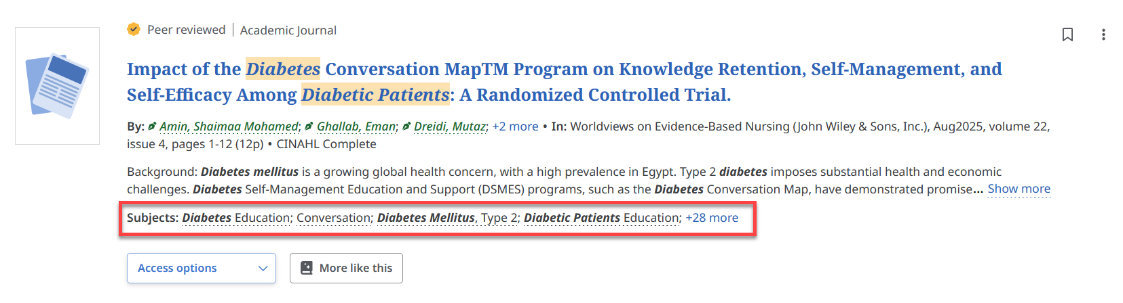

CINHAL Headings
- Click on “Advanced Search”
- Find the CINAHL Headings tab.
- Type in a topic and search the results for a new subject heading.
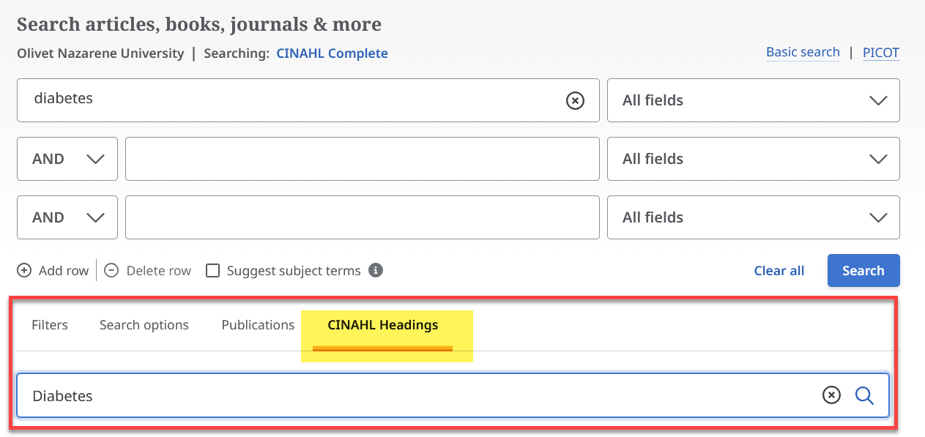
- Click the checkbox next to the CINAHL Heading you want
- Then scroll up to the top of the list to use the “Add to Search” button.
- Click the Search button to execute this new combination of terms.
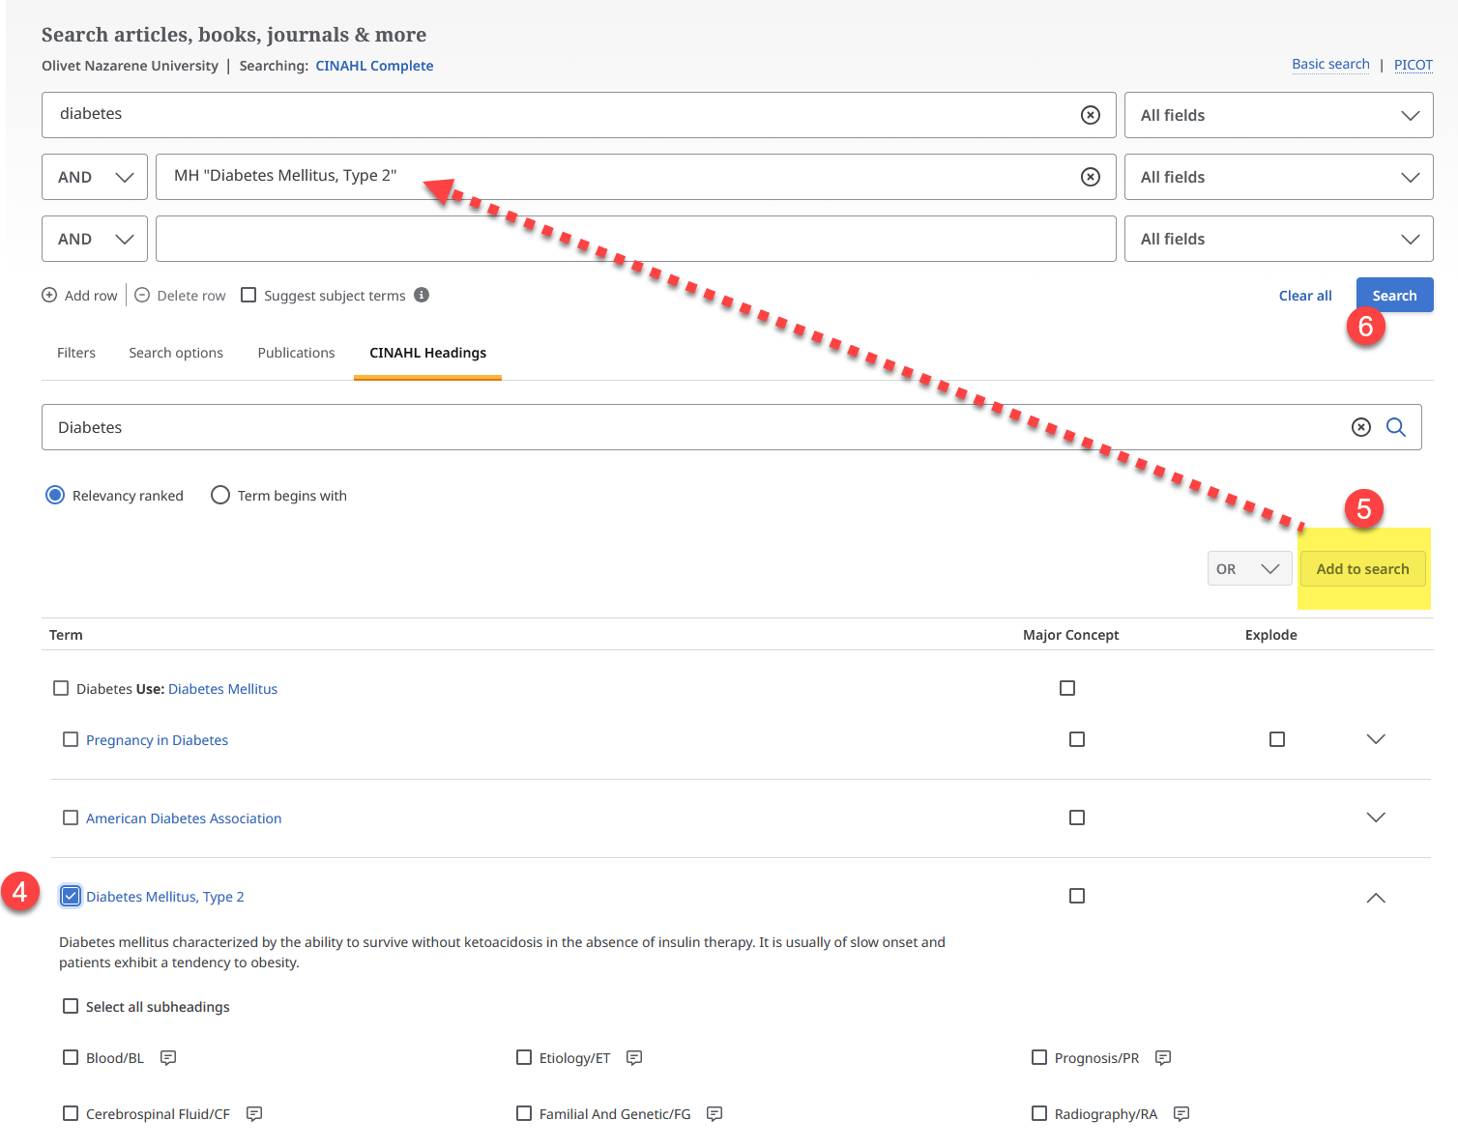
Try other search terms or subject headings to get even more refined searches. The article hit count can be greatly decreased with this search option.

The Article Interface
- Once an appropriate title is found, click on “Show More” or on the title to view the abstract. The abstract provides a quick overview of the article and can be used to determine if the article will be helpful in your research.
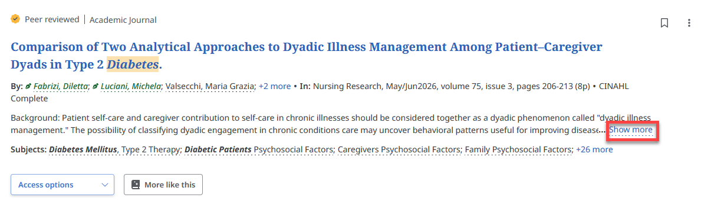
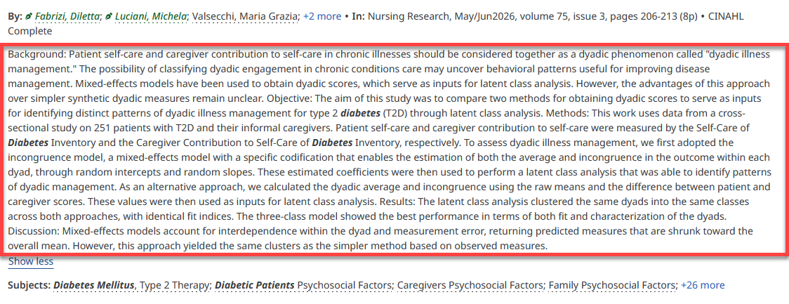
- To access the full text article, select Access Now or try “Check for fulltext.” If none of those options are available, the item can be requested through the Interlibrary Loan department -
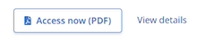
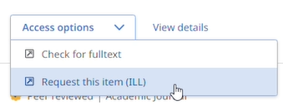

CINAHL tools
- Click on the article title to open the detailed view and to access additional tools.
- The toolbar on the top right provides options for saving the article for later, cite the article, add it to a project folder, share the article, or download the article.
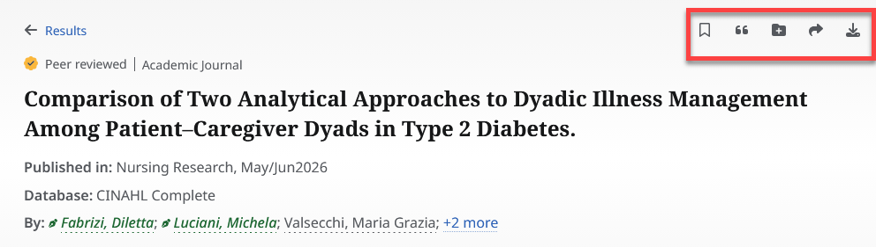
- The citation tool displays several citation formats.
Note: Although these citations are helpful, always check the format manual to ensure accuracy.
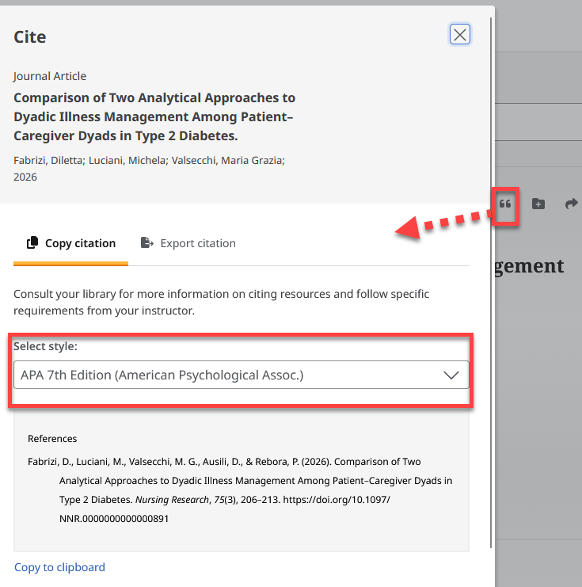
- Log in to your EBSCO account with ONU credentials in order to access saved articles after the current session.

Questions?
Contact the INFO desk at 815-939-5354

