Checking for Full Text
Finding full text sources is a critical skill for researchers.

Choosing a database

- Begin on the home page, library.olivet.edu
- To navigate to a list of databases:
  - Begin by clicking on Subject Guides
  - Then select A-Z eResources which is the first option on the page.
Many databases have various options to check for full text articles. For this tutorial we will use an EBSCO database, Academic Search Complete.
- Click on Academic Search Complete.
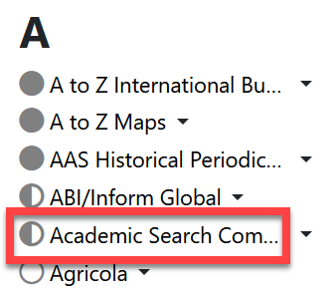

Access Options
The results list in EBSCO, as well as many other databases, may show any of the following four full text access options:
- Access now (online full text)
- Access Now (PDF)
- Access Options
  - PDF or Online full text
  - Check for full text or Request this item (ILL)
- The Access now (online full text) button links to the full text page which displays the articles plainly and lacks the original fonts, formats, and colors. Any images in the article will likely be linked separately or may not be included at all.
- The Access now (PDF) button links to the PDF version of the article. This version is like a photocopy of the original article.
- If the button says Access Options, the HTML full text or PDF full text may be available through our library or a partner library. Click to find out! When you click on the Access options button you will either see:
  - Direct links to the .pdf or .html content
  - Options to check for the full text.
If you see “PDF” or “Online full text,” click to connect.
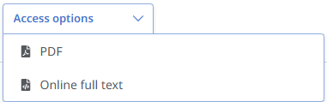
If no full text is available in this database, you will be presented with two different options:
- Check for fulltext
- Request this item (ILL)
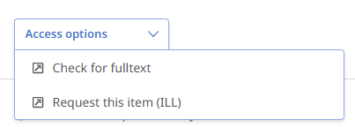
Clicking the “Check for fulltext” button could bring you to one of two results. Both will eventually get you the full text.
- If we have the article, you’ll be directed immediately to it in another library database.
- If we do not have it in our subscriptions, you will be taken to the library catalog.
    - Click “Sign in” to the database get to the request link.
    - Click on “Request this item (ILL)”
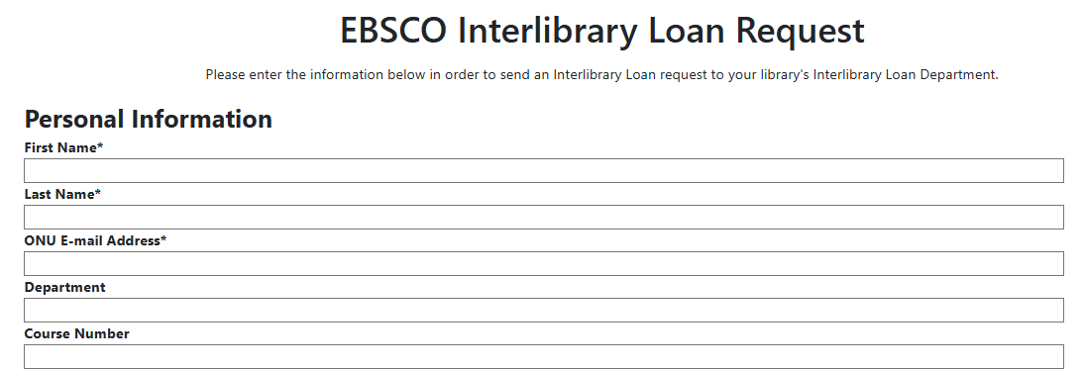
    - Fill out the required fields with your Olivet information.
    - Check the pre-filled article citation for accuracy before submitting the form.
After you submit this form, our Interlibrary Loan team will get a notification of your request and then contact a partner library to send it to your Olivet email. You can keep the article PDF forever at no cost to you.
Some publishers wait six, twelve, or even eighteen-months before they contribute their newest content to library databases. To circumvent these embargos, modify your search to eighteen months before the current date.

Contacts for Additional Help:
- INFO Desk: 815-939-5354 or ONULibrary@olivet.edu
- Circulation: 815-928-5441 or Circulation@olivet.edu
- Interlibrary Loan: 815-928-5439 or ILL@Olivet.edu

