Button Site Tutorial
The Irene Clerico Maker Space, located in the lower level of Benner Library, offers specialty services for patrons to use, including button making. Design your own button or use an online tool linked from the Benner Library website.

Step 1:
To design your button, go to library.olivet.edu.
- Click on “Services” in the navigation bar at the top of the page
- Choose “Button Making” from the list of services.
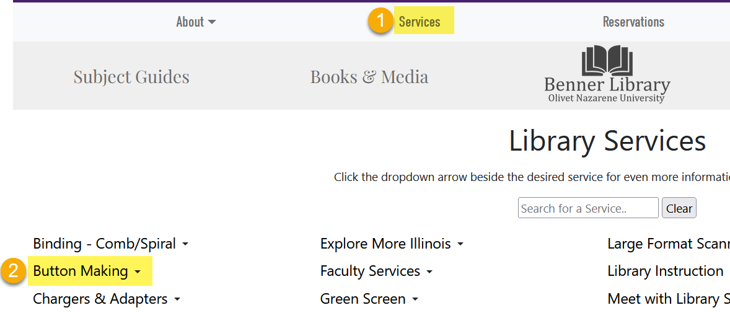

Step 2:
- From the Button Making Services page, click the link to the design section of Buttonmakers.net.
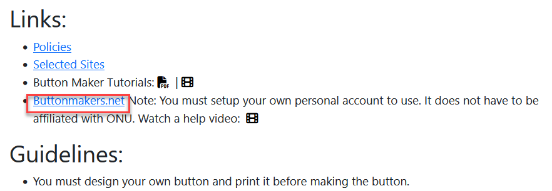
- Create a free account on Buttonmakers.net.
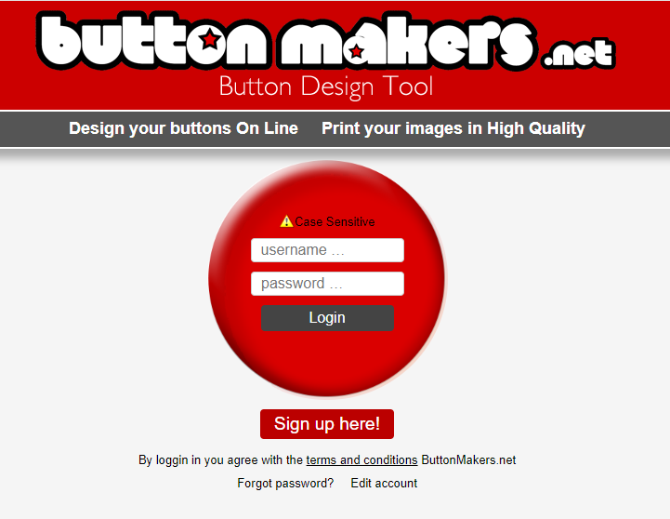
- Once you have created your account and logged in, you will be able to customize your button.
- Be sure to select the correct size before customizing. Our supplies accommodate 1.5-inches and 2.25-inches.
- To change or remove text elements, click on the corresponding green button(s) on the bottom of the screen.
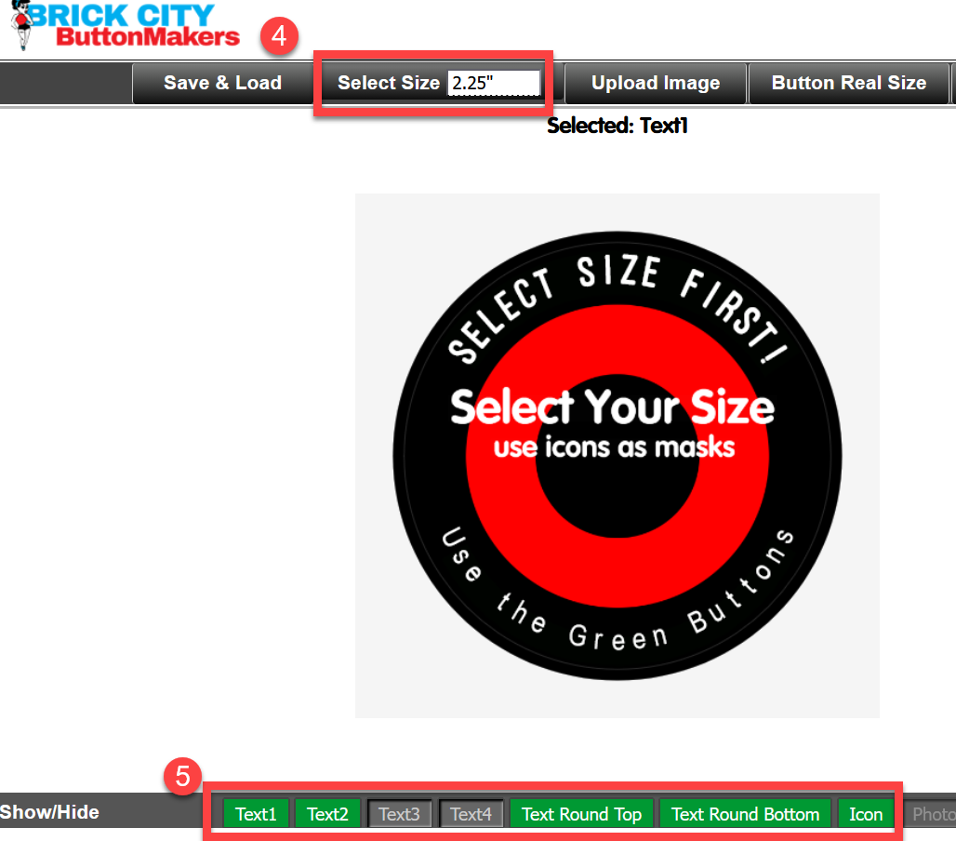
- Unselect all text elements (see step 5) and click on the background of the button in order to change the color.
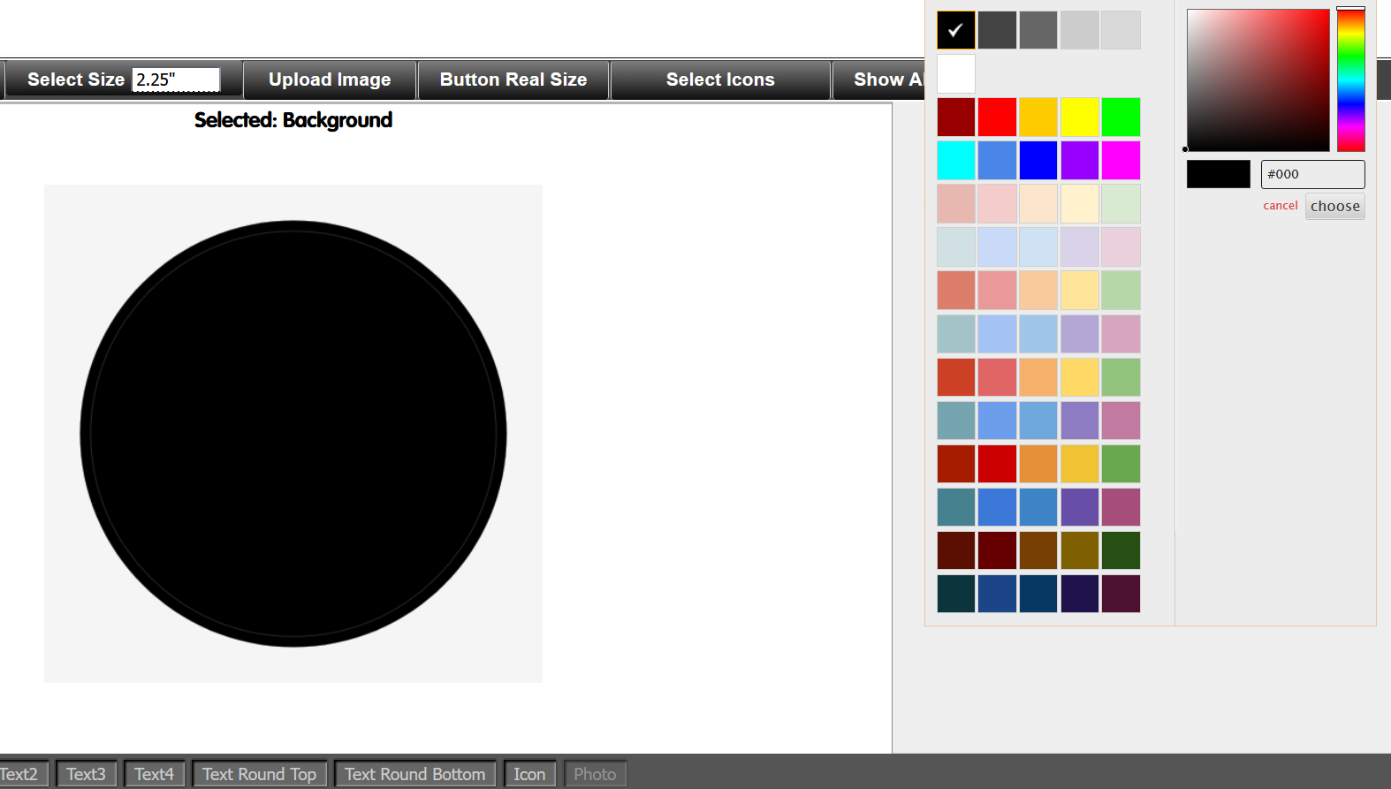
- To save your design:
  - Click “Save & Load” from the top tool bar
  - Choose “Save this Button”
  - Important! SAVE your design before you click “Print Your Buttons.”
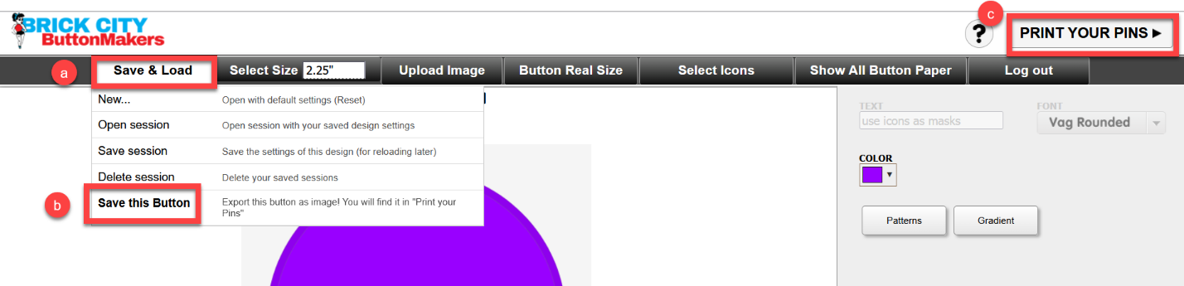
- To print your buttons:
  - Click “Print Your Buttons” (step 7c)
  - Choose “Make a print-sheet with the selected button” to generate a .pdf with a letter-sized sheet of duplicate images of the newly saved button
  - Now you can save this print sheet for future use or print it.

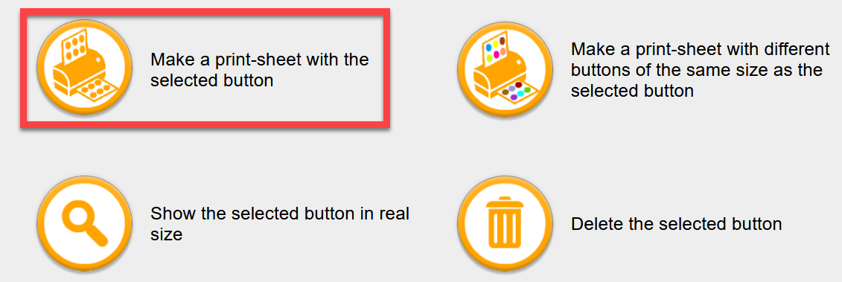

Questions?
For additional help, visit the Service Desk located on the Lower Level of Benner Library.

